Computer Science 323
Fall 2018

Final Project

Simon Lee
Cirjeffrey Baldomero

Method Used: Top-Down Parser (table I)
Language Used: C++

Original Grammer

<prog> | -> | Program <id> ; var <dec-list> begin <stat-list> end
<id> | -> | <letter> {<letter> | <digit>}
<dec-list> | -> | <dec> : <type> ;
<dec> | -> | <id> , <dec> | <id>
<type> | -> | integer
<stat-list> | -> | <stat>|<stat><stat-list>
<stat> | -> | <write> | <assign>
<write> | -> | Show (<id>);
<assign> | -> | <id> = <expr> ;
<expr> | -> | <expr> + <term> | <expr> - <term> | <term>
<term> | -> | <term> * <factor> | <term> / <factor> | <factor>
<factor> | -> | <id> | <number> | (<expr>)
<number> | -> | <sign> <digit> {<digit>}
<sign> | -> | +|-|λ
<digit> | -> | 0|1|2|...|9
<letter> | -> | a|b|c|d|e

BNF Form
<prog> -> program <id>; var <dec-list>; begin <stat-list>; end
<id> -> <letter> <id2>
<id2> -> <letter> <id2>
<id2> -> <digit> <id2>
<id2> -> null

<dec-list> -> <dec>:<type>;
<dec> -> <id>, <dec2>
<dec2> -> <dec>
<dec2> -> <id>
<type> -> integer

<stat-list> -> <stat> <stat-list2>
<stat-list2> -> <stat>
<stat-list2> -> null

<stat> -> <write>
<stat> -> <assign>

<write> -> (<id>);
<assign> -> <id> = <expr>;

<expr> -> <expr> + <term>
<expr> -> <expr> - <term>
<expr> -> <term>

<term> -> <term> * <factor>
<term> -> <term> / <factor>
<term> -> <factor>

<factor> -> <id>
<factor> -> <number>
<factor> -> (<expr>)

<number> -> <sign><digit><digit2>
<digit2> -> <digit> <digit2>
<digit2> -> null

<sign> -> +
<sign> -> -
<sign> -> null

<digit> -> 0
<digit> -> 1
<digit> -> 2
<digit> -> 3
<digit> -> 4
<digit> -> 5
<digit> -> 6
<digit> -> 7
<digit> -> 8
<digit> -> 9

<letter> -> a
<letter> -> b
<letter> -> c
<letter> -> d
<letter> -> e

First And Follow
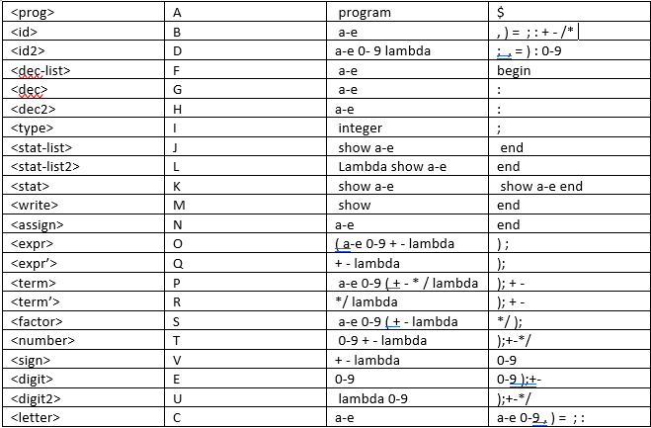

Parsing Table

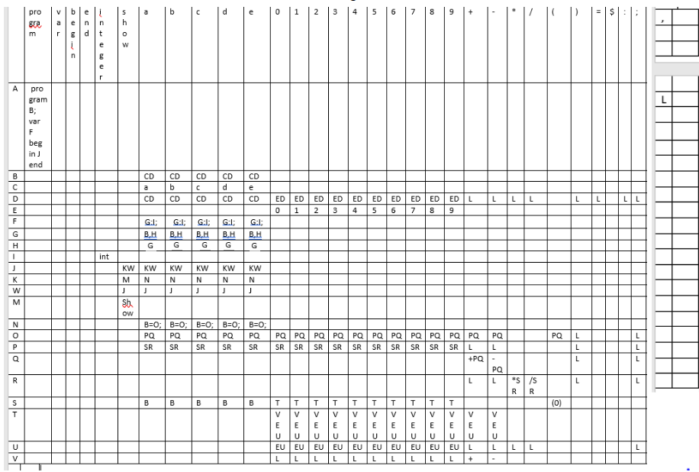
Program For Part 1

//Program’s function is to take in a given text file and output it’s contents into another file with //proper syntax

#include <iostream>
#include <fstream>
#include <sstream>
#include <string>
using namespace std;

void writeFile(string);
bool comment = false;
bool singleComment = false;
void parseToken(string);

int main() {
string line;
ifstream inFile;
inFile.open("finalp1.txt");
remove("finalp2.txt"); // clears file during each run

while (getline(inFile, line)) { // while there are lines to get from file

istringstream iss(line); // convert line into separate tokens

if (line != "" && line[1] != '/') { // check if line is empty or single line comment only
while (iss) {

string tok;
iss >> tok; // converts tokens to strings to be analyzed

if (tok == "/*") { // checks for multi line comment
comment = true;
}
if (tok== "*/") {
comment = false;
break;
}
parseToken(tok);
}
}
}

system("pause");
}

// function parses each individual token.
void parseToken(string token) {
if (token[0] == '/' && token[1] == '/') { // checks for mid line comment
singleComment = true;
}

writeFile(token);

if (token == "" ) { // checks for end of line and pushes a newline
if (singleComment) { // checks for end of line for single line comments
singleComment = false;
}
writeFile("\n");
}
}

// opens and appends to file if not in comment state
void writeFile(string token) {
if (comment != true && singleComment != true) {
ofstream outFile;
outFile.open("finalp2.txt", ::ios_base::app);
outFile << " " << token;
outFile.close();
}
}

PROGRAM FOR PART 2

#include <iostream>
#include <stack>
#include <string>
#include <vector>
#include <sstream>
#include <iterator>
using namespace std;
void showStack(stack<string> s);
int getRow(string r);
int getCol(string c);

bool isAccepted(vector<string> w, size_t length, stack<string>s) {
string table[22][32] = {
// P V B EN I S A B C D E 0 1 2 3 4 5 6 7 8 9 + - * / ( ) = $ : ; ,
"program B ; var F begin J end","", "", "", "", "", "", "", "", "", "", "", "", "", "", "", "", "", "", "", "", "", "", "", "", "", "", "", "", "", "", "", //A
"", "", "", "", "", "", "C D", "C D", "C D", "C D", "C D", "", "", "", "", "", "", "", "", "", "", "", "", "", "", "", "", "", "", "", "", "", //B
"", "", "", "", "", "", "a", "b", "c", "d", "e", "", "", "", "", "", "", "", "", "", "", "", "", "", "", "", "", "", "", "", "", "",//C
"", "", "", "", "", "", "C D", "C D", "C D", "C D", "C D", "E D", "E D", "E D", "E D", "E D", "E D", "E D", "E D", "E D", "E D", "L", "L", "L", "L", "", "L", "L", "", "L", "L", "L",//D
"", "", "", "", "", "", "", "", "", "", "", "0", "1", "2", "3", "4", "5", "6", "7", "8", "9", "", "", "", "", "", "", "", "", "", "", "",//E
"", "", "", "", "", "", "G : I ;", "G : I ;", "G : I ;", "G : I ;", "G : I ;", "", "", "", "", "", "", "", "", "", "", "", "", "", "", "", "", "", "", "", "", "",//F
"", "", "", "", "", "", "B , H", "B , H", "B , H", "B , H", "B , H", "", "", "", "", "", "", "", "", "", "", "", "", "", "", "", "", "", "", "", "", "",//G
"", "", "", "", "", "", "G", "G", "G", "G", "G", "", "", "", "", "", "", "", "", "", "", "", "", "", "", "", "", "", "", "", "", "",//H
"", "", "", "", "integer", "", "", "", "", "", "", "", "", "", "", "", "", "", "", "", "", "", "", "", "", "", "", "", "", "", "", "",//I
"", "", "", "", "", "K W", "K W", "K W", "K W", "K W", "K W", "", "", "", "", "", "", "", "", "", "", "", "", "", "", "", "", "", "", "", "", "",//J
"", "", "", "", "", "M", "N", "N", "N", "N", "N", "", "", "", "", "", "", "", "", "", "", "", "", "", "", "", "", "", "", "", "", "",//K
"", "", "", "L", "", "J", "J", "J", "J", "J", "J", "", "", "", "", "", "", "", "", "", "", "", "", "", "", "", "", "", "", "", "", "",//L
"", "", "", "", "", "show ( B ) ;", "", "", "", "", "", "", "", "", "", "", "", "", "", "", "", "", "", "", "", "", "", "", "", "", "", "",//M
"", "", "", "", "", "", "B = O ;", "B = O ;", "B = O ;", "B = O ;", "B = O ;", "", "", "", "", "", "", "", "", "", "", "", "", "", "", "", "", "", "", "", "", "",//N
"", "", "", "", "", "", "P Q", "P Q", "P Q", "P Q", "P Q", "P Q", "P Q", "P Q", "P Q", "P Q", "P Q", "P Q", "P Q", "P Q", "P Q", "P Q", "P Q", "", "", "P Q", "L", "", "", "", "L", "",//O
"", "", "", "", "", "", "S R", "S R", "S R", "S R", "S R", "S R", "S R", "S R", "S R", "S R", "S R", "S R", "S R", "S R", "S R", "L", "L", "", "", "", "L", "", "", "", "L", "",//P
"", "", "", "", "", "", "", "", "", "", "", "", "", "", "", "", "", "", "", "", "", "+ P Q", "- P Q", "", "", "", "L", "", "", "", "L", "",//Q
"", "", "", "", "", "", "", "", "", "", "", "", "", "", "", "", "", "", "", "", "", "L", "L", "* S R", "* S R", "", "L", "", "", "", "L", "",//R
"", "", "", "", "", "", "B", "B", "B", "B", "B", "T", "T", "T", "T", "T", "T", "T", "T", "T", "T", "", "", "", "", "( O )", "", "", "", "", "", "",//S
"", "", "", "", "", "", "", "", "", "", "", "V E U", "V E U", "V E U", "V E U", "V E U", "V E U", "V E U", "V E U", "V E U", "V E U", "V E U", "V E U", "", "", "", "", "", "", "", "", "",
"", "", "", "", "", "", "", "", "", "", "", "E U", "E U", "E U", "E U", "E U", "E U", "E U", "E U", "E U", "E U", "L", "L", "L", "L", "", "", "", "", "", "L", "",//U
"", "", "", "", "", "", "", "", "", "", "", "L", "L", "L", "L", "L", "L", "L", "L", "L", "L", "+", "-", "", "", "", "", "", "", "", "", "", };//V
bool found = false;
string t; //the popped char
int r; //the row number
int c; // the column number
string e; //the string in specified index from table
vector<string> reserved_words = { "program","var","begin","show","end","integer" };
//check for reserved words
for (int h = 0; h < reserved_words.size(); h++) {
for (int g = 0; g < w.size(); g++) {
if (reserved_words[h] == w[g]) {
found =true;
}
}
if (!found)

{
cout << reserved_words[h] << " is expected" << endl;
return false;
}
}
string h;
bool is_reserved;
s.push("$");
s.push("A");
t = s.top();
s.pop();
//this while loop will never finish because the function returns true or false
//once it matches $ or " " during each iteration
int num_of_commas = 0;
int curr_comma = 0;
for (int k = 0; k < 1; k++) {
if (w[k] == ",")
num_of_commas++;
}
//check the program to determine if accepted or not
for (int j = 0; j < w.size(); j++) {
int i = 0; //read index for the terminal
int f; //the number of times we need to check if reserved word we only need to
//check once, otherwise check each individual character
int token_size = 1; //for reserved words the size of token is the whole string
//for the other terminals its one
f = w[j].size(); //the amount of times we need to check

//check if the token is a reserved word
for (int z = 0; z < reserved_words.size(); z++) {
if (w[j] == reserved_words[z]) {
cout << "RESERVED WORD: " << w[j].substr(i, w[j].size()) << endl;
token_size = w[j].size();
f = 1;
}
}
//check if variable is not defined

//check each token
while (i < f) {

int r = getRow(t);
int c = getCol(w[j].substr(i, token_size));
e = table[r][c];
//error checking for ( is missing
if (t == "(" && w[j] == "a" || t == "(" && w[j] == "b" || t == "(" && w[j] == "c" ||
t == "(" && w[j] == "d" || t == "(" && w[j] == "e") {
cout << "( is missing " << endl;
return false;
}
//error checking for ) is missing
if (t == ")" && w[j] == ";") {
cout << ") is missing " << endl;
return false;
}
if (t == ",") { //keep count of the num of commas

curr_comma++;
cout << "curr_comma " << curr_comma << endl;
}
if (t == "H") { //change dec to <id> in table if we reach the last variable declaration
if (curr_comma == 3) {
cout << "change G to B" << endl;

e = "B";
}
}

if (t == "$") {
return true;
}
//match pop and go to next token in vector w
else if (t == w[j].substr(i, token_size)) {
cout << "stack before popping after match" << endl;
showStack(s);
t = s.top();
s.pop();
i++;
}
else if (e == "") { //rejected
if (t == "D" && w[j] == "var" || t == "D" && w[j] == "begin" || t == "U" && w[j] != ";")
cout << ";" << " is missing" << endl;
else if (t == "R" && w[j] == "(" || t == "E" && w[j] == "+"|| t == "E" && w[j] == "-"|| t == "E" && w[j] == "*"|| t == "E" && w[j] == "/")
cout << "illegal expression" << endl;

return false;
}
else if (e == "L") //if lambda pop stack
{
cout << "lambda at row " << r << "col " << c << endl;
t = s.top();
s.pop();

}
//push the entry in specified row and col
else {
cout << "pushing at row " << r << "col " << c << endl;
std::string str = e;
std::istringstream buf(str);
std::istream_iterator<std::string> beg(buf), end;

std::vector<std::string> tokens(beg, end); // done!

for (auto& s : tokens)
std::cout << '"' << s << '"';
cout << endl;
for (int j = tokens.size() - 1; j >= 0; j--) {
s.push(tokens[j]);
}
cout << "stack after pushing e" << endl;
showStack(s);
t = s.top();
s.pop();

}

}
if (w[j] == "end") {
cout << "no error" << endl;
return t == "$";
}
}
return false;
}

void showStack(stack<string> s) {
for (std::stack<string> dump = s; !dump.empty(); dump.pop())
std::cout << dump.top() << " ";

}
int main() {

vector<string> arr = { "program" ,"a2018" , ";","var","ab1",",","cd",",","e33a",",","d18",":","integer",";","begin",
"ab1","=","33",";","cd","=","41",";","e33a","=","5",";","show", "(" , "ab1" , ")", ";" ,
"d18" , "=" , "ab1", "*" , "(" , "cd" , "+" , "2" , "*" , "e33a" , ")" , ";" , "show" , "(" ,
"d18" , ")" , ";" , "end"};
stack<string> s;

bool isaccep;
isaccep = isAccepted(arr, arr.size(), s);
if (isaccep)
cout << "accepted" << endl;
else
cout << "rejected" << endl;

system("pause");
return 0;
}
int getRow(string r) { //get row number associated with non-terminal
int x = 0;
if (r == "A") { x = 0; }
else if (r == "B") { x = 1; }
else if (r == "C") { x = 2; }
else if (r == "D") { x = 3; }
else if (r == "E") { x = 4; }
else if (r == "F") { x = 5; }
else if (r == "G") { x = 6; }
else if (r == "H") { x = 7; }
else if (r == "I") { x = 8; }
else if (r == "J") { x = 9; }
else if (r == "K") { x = 10; }
else if (r == "W") { x = 11; }
else if (r == "M") { x = 12; }
else if (r == "N") { x = 13; }
else if (r == "O") { x = 14; }
else if (r == "P") { x = 15; }
else if (r == "Q") { x = 16; }
else if (r == "R") { x = 17; }
else if (r == "S") { x = 18; }
else if (r == "T") { x = 19; }
else if (r == "U") { x = 20; }
else if (r == "V") { x = 21; }

return x;
}
int getCol(string c) { //get the column number associated with terminal
int y = 0;
if (c == "program") { y = 0; }
if (c == "var") { y = 1; }
if (c == "begin") { y = 2; }
if (c == "end") { y = 3; }
if (c == "integer") { y = 4; }
if (c == "show") { y = 5; }
if (c == "a") { y = 6; }
if (c == "b") { y = 7; }
if (c == "c") { y = 8; }
if (c == "d") { y = 9; }
if (c == "e") { y = 10; }
if (c == "0") { y = 11; }
if (c == "1") { y = 12; }
if (c == "2") { y = 13; }
if (c == "3") { y = 14; }
if (c == "4") { y = 15; }
if (c == "5") { y = 16; }
if (c == "6") { y = 17; }
if (c == "7") { y = 18; }

if (c == "8") { y = 19; }
if (c == "9") { y = 20; }
if (c == "+") { y = 21; }
if (c == "-") { y = 22; }
if (c == "*") { y = 23; }
if (c == "/") { y = 24; }
if (c == "(") { y = 25; }
if (c == ")") { y = 26; }
if (c == "=") { y = 27; }
if (c == "$") { y = 28; }
if (c == ":") { y = 29; }
if (c == ";") { y = 30; }
if (c == ",") { y = 31; }
return y;
}

SAMPLE RUN
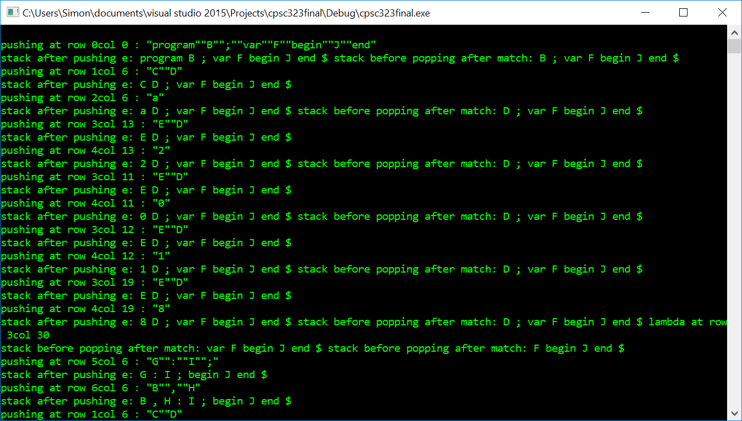

End result
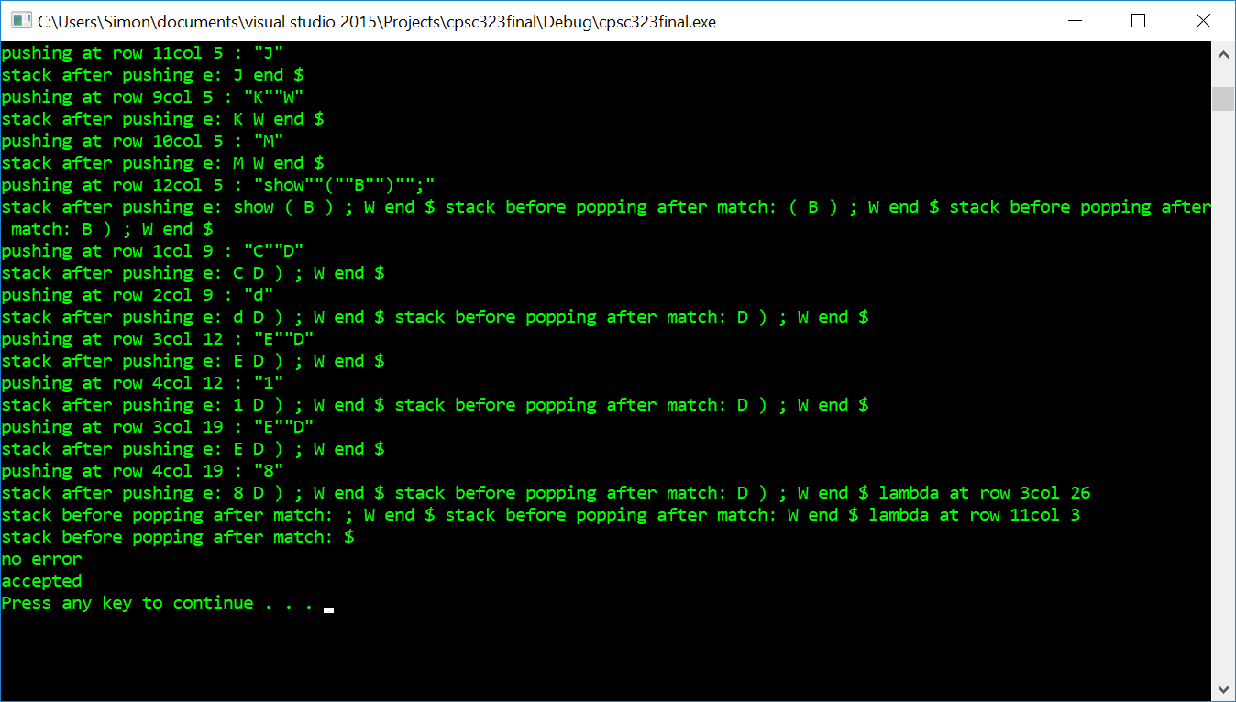
PART 3 PROGRAM
// Program reads text file and converts to high level c++ language with error checking
#include <iostream>
#include <string>
#include <fstream>
#include <vector>
#include <sstream>
#include <algorithm>
using namespace std;

int main() {
vector<string> v;
ifstream f;
string s;
f.open("finalp2.txt");
remove("finalp3.txt");
if (!f.is_open()) {
cout << "error cant open file" << endl;

}
while (!f.eof()) {
getline(f, s);
istringstream iss(s);
while (iss) {
string tok;
iss >> tok;
v.push_back(tok);
}
}
f.close();
ofstream a;
a.open("finalp3.cpp");
a << "#include <iostream>";
a << endl;
a << "using namespace std;";
a << endl;
a << "int main()\n";

a << "{\n";
/*for (string s : v) {
cout << s << endl;
}*/
vector<string>::iterator start;
vector<string>::iterator end;
vector<string> variables;
int index2 = 0;
start = find(v.begin(), v.end(), "var");

end = find(v.begin(), v.end(), ":");
a << "int ";
for (start; start != end; start++) {
if(*start != "var")
a << *start;
if (*start == ";")

a << endl;
}
a << ";\n";
start = find(v.begin(), v.end(), "begin");
end = find(v.begin(), v.end(), "end");
bool isShow = false;
for (start + 1; start != end; start++) {
if (*start == "begin") {}
else if (isShow && *start == "(" || isShow && *start == ")") {

}

else if (*start == "show") {

a << "\ncout << ";
isShow = true;

}
else if (*start == ";")
{
a << *start;
a << endl;
isShow = false;
}
else
a << *start;
}
a << "return 0;\n";
a << "}";
system("pause");
return 0;
}
Output
High level language code created by previous program reading text file
#include <iostream>
using namespace std;
int main()
{
int ab1,cd,e33a,d18;
ab1=33;
cd=41;
e33a=5;
cout << ab1;
d18=ab1*(cd+2*e33a);

cout << d18;
return 0;
}

